**DAY 4**

Agenda: The Flag Hoist, An Introduction to Functions

**Materials:** Two copies of The Flag Hoist for each group and 2 copies of Representing Functions for each group.

**INTRODUCTION TO FUNCTIONS  
THE FLAG HOIST:** Have students get into their groups and give each group a copy of the Flag Hoist handout. Their assignment is to consider each of the graphs to consider how it might represent the action of the smallest boys scout raising the flag, and to decide which on BEST represents hoisting the flag. Give them about 5 minutes to talk in their groups.

Then lead a whole class discussion of which one they think is best. Be sure several views are presented, and ask them about some of the ones they don’t choose and why not. In particular bring up the vertical line (ideally later in the discussion) and whether it is even a possibility. Toward the end of the discussion ask them if all of the graphs represent functions, and ask which do and which do not and their reasons. This should get you to the basic definition of a function.

Then hand out Activity 4. Representing Functions

**REPRESENTING FUNCTIONS**Introduce the first problem by putting the following graph on the board and asking students to figure out the story.

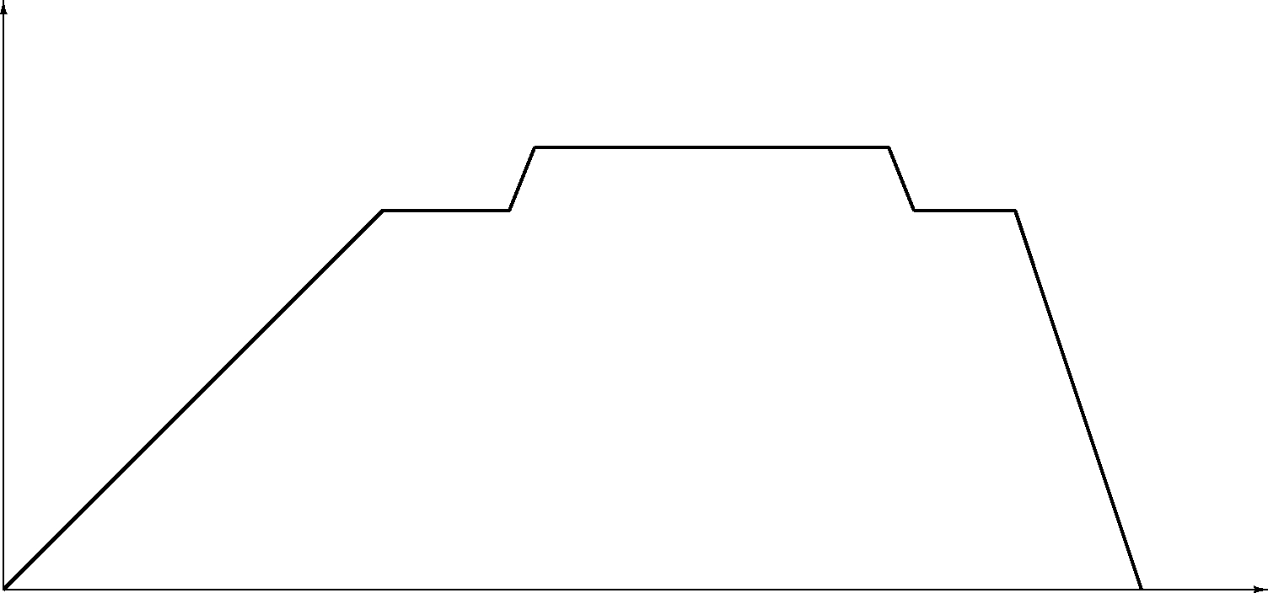

Time

Level of Water in Bath Tub

Someone should say something like the tub started empty and it was filled with water. Then someone got in and the water level stayed the same while he or she took a bath. Then the bather got out and pulled the plug so it drained out very quickly.

Now ask students to work on the activity. When most groups have finished problem 1, have students tell their stories. Discuss the fact that the graphs are not linear. They are piecewise linear. Most graphs in the real world are not linear.

Tell students to continue working on the problems. This is an opportunity to see how much they know about linear functions and possibly deepen that knowledge. Circulate to listen in on each group and answer group questions, but don’t get bogged down having a long discussion with each group.

Check understanding group by group: by asking the person who appears to be least engaged or straggling a question probing their understanding of the table/graph/equation/situation connections. Some possible questions depending on the problem they are on:

How does the graph show which student saves the most money per week?

What would be the table entry for the y-intercept and what would it represent?

How did you explain the relationship of the number that multiplies the variable in the equation to the slope (or steepness) of the graph?

If the group member you asked answers, ask whether the rest of the group agrees or has anything to add. If the person hesitates and others start to jump in, suggest that the group members make sure everyone in the group can answer the question, and tell them you’ll be back to check. Then move on to another group, and do be sure to go back within a few minutes.

END OF CLASS SUMMARIZE

Discuss problems 2 and 3

try to have several students articulate why the *y-intercept* is the number added to the term with the variable. They should be able to come up with the fact that the variable term disappears when the variable is zero. Also they should state that the slope is the multiplier for the variable or amount that is multiplied by the variable. They can see more clearly in the table that each time they increase the number of weeks by one; the amount saved goes up by the amount of the slope. It is really important that students articulate these notions in their own words, rather than listen passively to you expressing these ideas “correctly.”

HOMEWORK [from 1.1 & 1.2]  
Possibilities to choose from: Section 1.1: 2, 4, 6, 8, 20, 22, 26  
Section 1.2: 12, 14

**DAY 5**

Agenda: The definition of a function and in-out tables.

Materials: One copy of The Ins and Outs of Functions for each group.

GETTING STARTED

**Silent Board Game**

First put an In-Out table like the one below on the board, based on *y =* 2*x* + 3. Just put up the incomplete table, do not reveal the equation. Doing this in silence will allow more people to participate, maybe some who have not been willing before. It should also keep people from shouting out the rule.

|  |  |  |  |  |  |  |  |  |  |
| --- | --- | --- | --- | --- | --- | --- | --- | --- | --- |
| x | 2 | 8 | 4 | –3 | 0 | –1 | 10 |  |  |
| y | 7 |  | 11 |  |  | 1 |  |  |  |

Tell students that this is a **Silent Board Game** so no one can talk including you (after you call for silence). Ask if anyone can fill in another number in the output row of the table. Now silence. Offer the board pen to a volunteer, who will need to come up and fill in **one** number in the second row. If it is correct, nod enthusiastically, if not shed a tear and sadly erase. If no one volunteers fill in another output and offer the marker again. Keep going. to get as many different people to come up as possible. Each person only once. Extend list of input numbers when you run out. If some are still stumped put in 100 or 1000. When you think most people have figured out the function rule, choose a variable like *p* as an input and offer the marker to a student to give the output.

Tell students that this unit will focus on functions and things one can do to them such as connect them and stretch them and move them around. They need to be familiar with ways of working with functions when they get to calculus. We will begin with the idea of a function as a machine. It will be useful in building a concrete understanding of how they work. Function machines are often called In-Out machines. Draw one on the board:



Functions are always smiling because they like their work, which is giving an output for any input. We drop something in the top, usually a number, and the machine grinds a bit and something drops out the bottom, usually another number.

GROUP WORK ON: THE INS AND OUTS OF FUNCTIONS

Give one copy of The Ins and Outs of Functions to each group and ask them to get started. If students have trouble with the first three problems, suggest they graph the points. If students need a further hint for problem 1, ask them what they can do to 6 to get close to 36. For problem 2, have them focus on the difference between the outputs for 1 and –1. For 3, you might have them focus on the order of magnitude of output for e, h, and b. So b is before e which is before h. For problem 4, ask what is true of all the outputs.

For problem 5, students can make up arbitrary machines that don’t fit the rule by giving a partial table with different outputs for the same input. Or they could think of the square root or any bigger number. For 5b, it could be any word with the input number of letters. For 5c, they could use a constant function or the squaring function.

SUMMARY

When most groups are working on problem 8 or when there are about 15 minutes left in class, begin whole class discussion. Ask various groups for the answers to the first 4 problems. Then get as many responses as possible for problems 5, 6 and 7. Discuss whether the examples fit the definitions. We will come back to the definitions, but try to correct misconceptions.

If there is extra time, ask groups who completed problem 8 to try to stump the class.

As part of the homework tell students that for the next class they will need access to Desmos on their computer, an iPAD, or their phone.

HOMEWORK [from 1.1 & 1.2]  
Possibilities to choose from: Section 1.1: 48-54 evens  
Section 1.2: 46-50 evens

**DAY 6**

Agenda: Investigate functions through their graphs. Develop definitions of domain and range.

Materials: One copy of Investigating Graphs of Functions for each group.

GROUPWORK

Handout copies of The Ins and Outs of Functions. Introduce today’s groupwork by with a brief reminder of what is required in the “sketch” of a graph. Point out that in problem 3 they will be asked to make a table for values of *x* in the interval (–5, 6) and ask for someone to explain what values for x that means. Briefly introduce “interval notation” as a really efficient way to describe a set of numbers on a number-line. They should be able to interpret closed and open intervals using () and []. This should take no more than 5 minutes, then put the groups to work on the problems.

Circulate and check in with groups to respond to their questions and be sure they are clearly labeling their graphs and describing the domains and ranges. Clarify any questions on interval notation in their groups if there is a need.

Not all groups need to finish all of problem 7.

Leave time for the groups that do finish to put their graphs, with the domains and ranges on the board.

SUMMARY

There may be time for a exit question.

HOMEWORK [from 1.1 & 1.2]  
Possibilities to choose from: Section 1.1: 34 – 46 evens   
Section 1.2: 16 – 40 even